Potential for Waste-to-Energy Plants in

Los Angeles County

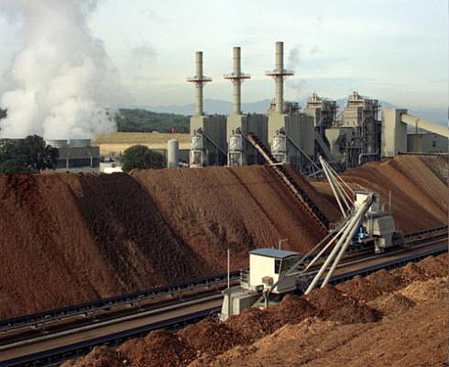

Hugo Sarmiento

Up206A

Waste-to-Energy (WTE) and Biomass in California
Waste-to-energy (WTE) power plants produce close to two percent of the total electricity in California from biomass: burning forestry, agricultural, and urban biomass – converting methane-rich landfill gas to energy and processing wastewater and dairy biogas into energy (California Energy Commission, 2010). And, there is no shortage of biomass, California residents create nearly 2,900 pounds of household garbage and industrial waste every second, producing a total of close to 85 million tons of waste annually (California Integrated Waste Management Board, 2010). Approximately half of this waste is recovered and recycled or used to make energy, however the other half has to be disposed in landfills.
Currently, there are about 132 WTE power plants in California, with a total capacity of almost 1,000 megawatts (MW). Twelve WTE power plants are located in Los Angeles County where they generate 187 MW of electricity compared to 28 hydroelectric and 89 natural gas plants which generate 10,570 MW and 10,935 MW respectively. (See maps below)

WTE, Hydro and Natural Gas Power Plants in Los Angeles County
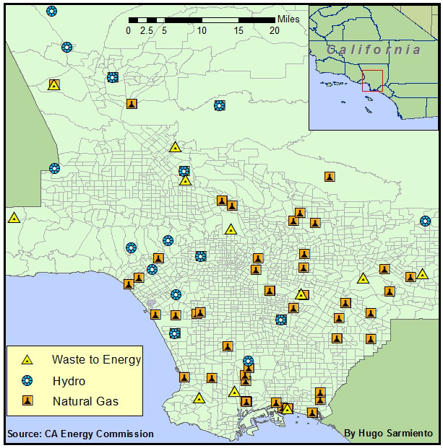

Megawatts of Electricity Generated by WTE, Hydroelectric
and Natural Gas Power Plants in Los Angeles County

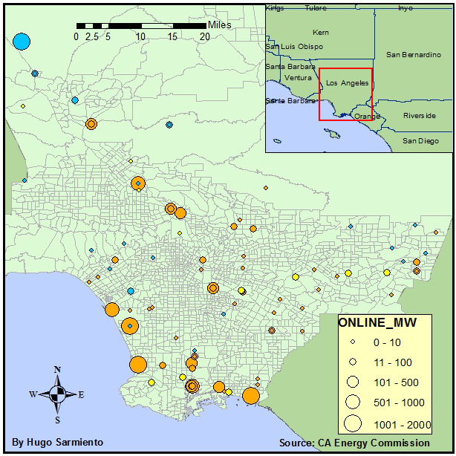

Why Does Waste-to-Energy Matter?
Using biomass to produce electricity reduces reliance on fossil fuels, the largest contributors to greenhouse gas emissions (GHG). Additionally, fossil fuels are a finite energy source which will eventually run out. Lastly, fossil fuels such as natural gas and petroleum are often found in politically unstable parts of the world making these sources of energy expensive.
On the other hand, biomass is renewable; human activity will always create waste. And, waste-to-energy facilities eliminate the need to place biomass in landfills. Landfills not only produce unpleasant odor but also produce biomethane gas which can pose a public health threat to surrounding communities up to a distance of a mile.

Policy Background
In 2006, California passed the Global Warming Solutions Act (AB 32) and established the Renewables Portfolio Standard (RPS) which codified the goal of increasing the percentage of renewable energy in the state’s electricity mix to 20% by 2010. This goal was supported by the state’s Energy Action Plan which added increasing the target to 33% by 2020. The RPS program requires electric utilities and providers to increase procurement from eligible renewable energy sources by at least one percent of their sales annually until they reach the goals set by state’s Energy Action Plan. (California Energy Commission, 2010)

Additionally, the Governor issued an executive order addressing biomass and biofuels specifically. The order stated:

- By 2010, 20 percent of its biofuels need to be produced within California, increasing to 40 percent by 2020 and 75 percent by 2050.

- By 2010, 20 percent of the renewable electricity should be generated from biomass resources within the state; maintain this level through 2020.

- Establish a Bioenergy Action Plan to maximize the contributions of bioenergy toward achieving the state’s petroleum reduction, climate change, renewable energy, and environmental goals.

Policy Question
Framing waste-to-energy in terms of meeting the “triple-bottom-line” goals of environmental stewardship, healthy communities and economic justice, a strategy pioneered by organizations such as Green For All and the Apollo Alliance, can potentially bring the multiple stakeholders needed to increase the use of biomass to generate electricity. This approach to other emerging industries such as the “greening” of construction and retrofitting for energy efficiency, though not without significant challenges, has an established track record of success. For example, in Los Angeles SCOPE (Strategic Concepts in Organizing and Policy Education), convener of the LA Apollo Alliance, successfully mobilized community – with the promise of job creation - to pressure the City of Los Angeles to pass a city ordinance requiring the retrofitting of municipal buildings to meet certain LEED standards.

Local governments can be similarly pressured to create policy which both requires and incentivizes current landfill operators to invest in building their waste-to-energy capacity. The pertinent question is which communities will enthusiastically support such a campaign? And where are they located?

Before we begin the process of trying to identify these communities, first let’s take a closer at how waste-to-energy works.

Biomass and Waste-to-Energy Facilities
Biomass refers to carbohydrates and other compounds produced through photosynthesis consisting of plant materials and agricultural, industrial and municipal wastes and residues. The total estimated biomass resource potential of California is approximately 47 million tons (California Energy Commission, 2011).

As such there are several types of WTE facilities that utilize different types of biomass for fuel. The map below highlights plants of the three different types of WTE facilities found in Los Angeles County.

Three Types of WTE Facilities in Los Angeles County

Palos Verdes Energy Recovery
Facility Total Energy Facility

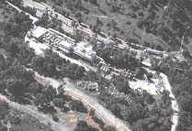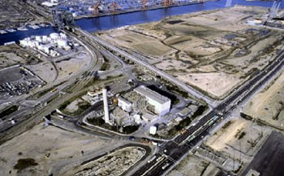

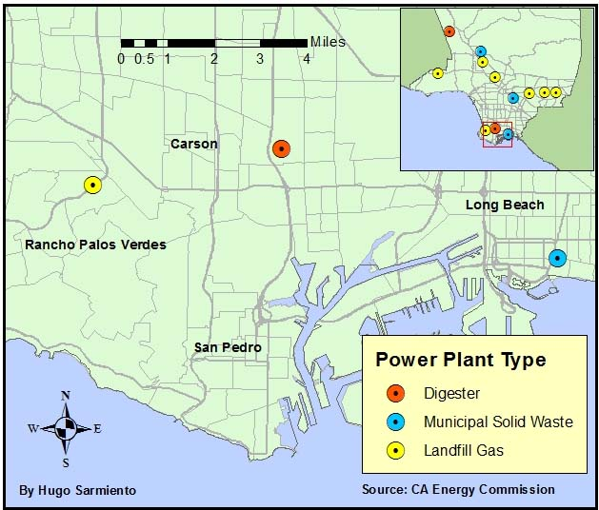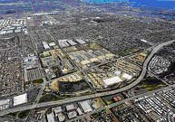
South East Resource Recovery Facility Facility

Digesters (Anaerobic Digestion)
Anaerobic digestion is one of three major WTE technologies. It is a biological process that produces a gas composed mainly of methane and carbon dioxide, also called biogas. These gases are produced from organic wastes such as livestock manure and food processing waste.

Digester facilities take waste and put it in airtight containers to catalyze the anaerobic breakdown of organic materials. The first step is the decomposition of plant or animal matter. This step breaks down the organic material to molecules such as sugar. Second, decomposed matter is converted to organic acids. Last, acids are converted to methane gas.

Municipal Solid Waste Power Plants
Municipal solid waste (MSW) is directly combusted in facilities for use as fuel with little processing in a process known as mass burn. In contrast to other WTE technologies, MSW facilities are paid by the fuel suppliers to take the fuel.

The process begins with incoming trucks which deposit refuse into pits, where cranes remove any bulky or non-combustible items. The refuse storage area is maintained under pressure less than atmospheric in order to prevent odors from escaping. The cranes then move the refuse to a combustor charging hopper to feed a boiler.

The heat from the combustion process is used to created steam which turns turbine-generators. According to the California Energy Commission, the resource potential of MSW in California is estimated as high as 2,000 MW, however, no new MSW facilities are currently planned for the state. A major factor for this is these facilities are less cost efficient than other WTE plants and in some cases face public opposition since they are usually sited close to urban centers in order to be close to waste generation..

Landfill Gas Power Plants
Landfill Gas based facilities are the main type of WTE power plants because it is also the main method for disposal of municipal and household wastes. Landfill waste is maintained in oxygen-free environments and relatively dry conditions but still produce large amounts of methane gas. This biomethane gas also has the tendency to migrate well beyond the parameters of the landfills. Thus, WTE facilities capture the gas by drilling wells into the landfill waste and using a system of plastic pipes to collect the naturally occurring gas.

Also, since landfill gas recovery facilities are already located at existing landfills, there are generally fewer issues with permitting or public opposition.

(California Integrated Waste Management Board, 2010)

Potential for New Waste-to-Energy Facilities
Having considered the various types of WTE facilities launching a campaign to build a new WTE facility in Los Angeles County would have to begin with identifying current landfills without WTE facilities. The maps below show the current locations of landfills in Los Angeles and population characteristics which should be taken into account when considering what kind of communities would support the opening of a new WTE facility.

The first map shows there are 11 landfills in Los Angeles and compares their location to levels of unemployment in the County (based on US Census Bureau data). Opening a new WTE facility would create jobs which would be an attractive proposition for communities experiencing high levels of unemployment.

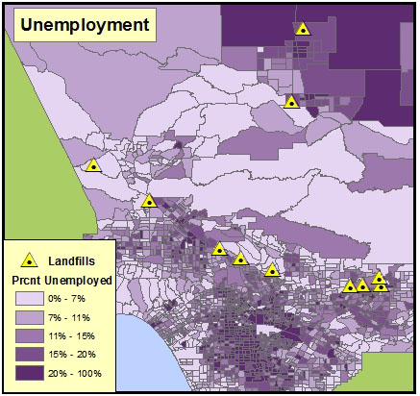

In general the public opposes the opening of landfills near their homes, thus the map below shows these sites where opened on the periphery of the more densely populated areas of the County. However, continuing the historic pattern of development in the areas, as development and populated areas expand from the center of the county outwards communities have begun to move in closer to these landfills. These communities would be concerned with potential biomethane gas migration from landfills which can migrate as far as a mile in distance and would potentially be interested in a WTE facility which can mitigate exposure to these toxic gases.

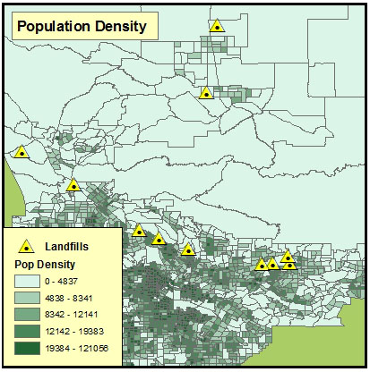

Understanding the social economic characteristics of the communities nearby these sites could potentially be very helpful in developing an organizing strategy focused on building a new WTE facility. For this reason it is useful to consider landfill sites in relation to median income levels as well as unemployment. The map below shows this relationship (median income levels are based on US Census Bureau data).

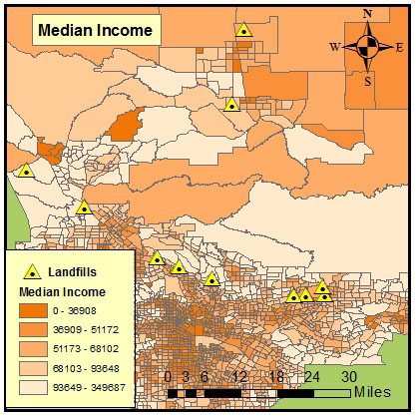

The map below shows a hotspot analysis which takes all three variables – population density, unemployment and median income levels. The darker areas show where in Los Angeles County populations are more densely settled, experience the highest levels of unemployment and have the lowest levels of income. Thus, assuming communities with these characteristics are more likely to support the building of a new WTE facility, a “WTE Support Index” is illustrated on the map with the number “5” representing the highest levels of support while the number “1” represents the lowest levels of support. According to this map, four landfills are located in areas of the San Gabriel Valley which rank high on the index. The following map focuses on these four landfills.

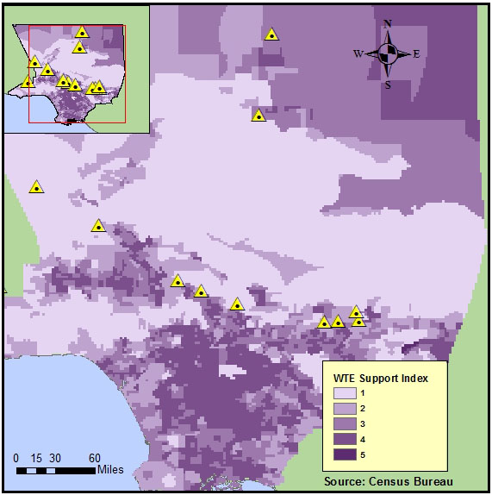

The following map provides a close-up view of the aforementioned four landfills – Azusa Land Reclamation, Nu-Way, Peck Road Gravel Pit and Vulcan Materials - which shows they cluster around the City of Irwindale. Nu-Way and Peck Road Gravel Pit are located within the city boundaries while the other two are just on the border. The table below produced with data from the Los Angeles County’s Department of Health shows they are all privately owned.

NAME | ADDRESS | CITY | STATE | ZIP | OPERATOR | TYPE
Azusa Land Reclamation | 1211 W. Gladstone St | Azusa | CA | 91702 | Waste Management Inc. | P / A / I
Antelope Valley | 1200 W. City Ranch Rd | Palmdale | CA | 93551 | Palmdale Disposal, Inc. | P
Brand Park | 1601 W. Mountain St | Glendale | CA | 91202 | City of Glendale DPW | Closed
Calabasas | 5300 Lost Hill Rd | Agoura | CA | 91301 | LA Co. Sanitation Dist. | P
Chiquita Canyon | 29201 Henry Mayo Dr | Valencia | CA | 91355 | Republic Services, Inc. | P
City of Burbank | 1600 Lockheed View Dr. | Burbank | CA | 91504 | City of Burbank | Private
Lancaster | 600 E. Ave. F | Lancaster | CA | 93535 | Waste Management, Inc. | P
Nu-Way | 13620 Live Oak Lane | Irwindale | CA | 91706 | Sanifill of Calif. Inc. | I
Pebbly Beach | 1 Dump Road | Avalon | CA | 90704 | Republic Services, Inc. | P
Peck Road Gravel Pit | 128 E. Live Oak Ave. | Monrovia | CA | 91016 | SLS&N Inc. | I
Reliance Pit #2 | 15990 Foothill Blvd. | Irwindale | CA | 91706 | Vulcan Materials | I
Scholl Canyon | 3001 Scholl Canyon | Glendale | CA | 91206 | LA Co. Sanitation Dist. | P
Sunshine Canyon | 14747 San Fernando Rd | Sylmar | CA | 91342 | BFI | P

Selecting the location of the City of Irwindale on the map provides important information regarding the community’s features. Irwindale residents have an average income of $30,000 and a poverty rate of 16.4 percent. And, forty six percent of its households have children under the age of 18. (US Census Bureau, 2010) These factors combined with high-unemployment rates, make this community a good prospect for launching a campaign to pressure local government officials to create policy that incentivizes and requires the private landfill owners to convert their landfills into WTE facilities.

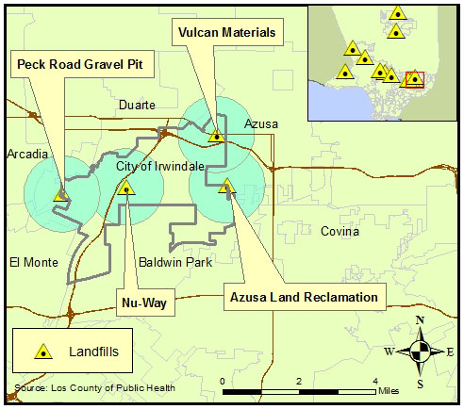

Conclusion
A spatial analysis of the location of current landfills in Los Angeles County compared to the surrounding communities’ characteristics reveals the community of Irwindale in the San Gabriel Valley is potentially a good launching point for efforts to bring more waste-to-energy power generation to the area. More research is needed, particularly with respect to political representatives who can be allies in this effort, as well as workers at the current landfills.

More broadly speaking, more research is needed on other landfills in Los Angeles County and the community’s that surround them. Ultimately, state wide regulatory policy will have to be developed to both pass regulations that require and incentivizes landfill operators to convert the waste-to-energy.

Finally, more research is needed on waste-to-energy technology itself, to ensure the desired outcomes concerning the environment and economic development are maximized.

References
California Energy Commission: http://www.energy.ca.gov/

Staff Draft Report 2011 Bioenergy Action Plan

Energy Action Plan, State of California, February 2008

California Integrated Waste Management Board, 2010: http://www.calrecycle.ca.gov/

County of Los Angeles Public Health: http://publichealth.lacounty.gov

